COMSATS University Islamabad Abbottabad Campus Department of Computer Science

Course: Object Oriented Programming Class: BSE-3C

Instructor: Nauman Khan Registration NO.: FA24-bse-144

Submitted by: Muhammad Talha Marks: 20 marks

**Lab Task 02 – Java Basics Practice**

Print Your Details

Write a Java program to print your name, age, and city on screen.

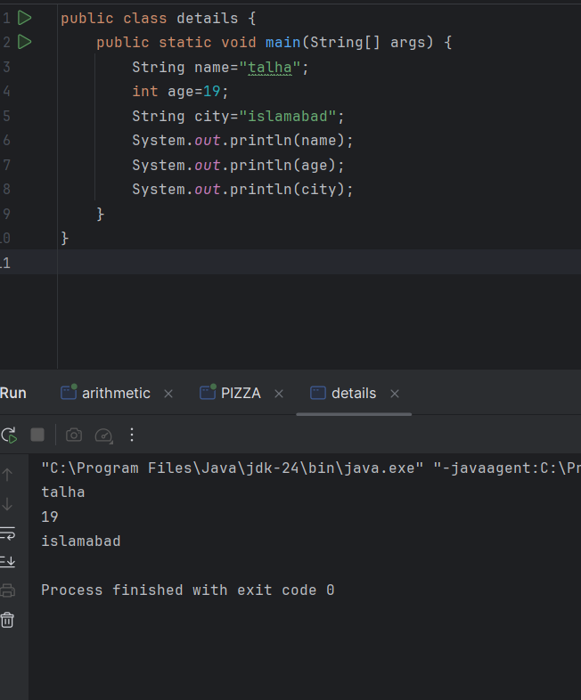

## Simple Arithmetic Calculator

Write a program that takes two numbers as input from the user and displays their sum, difference, product, and quotient.

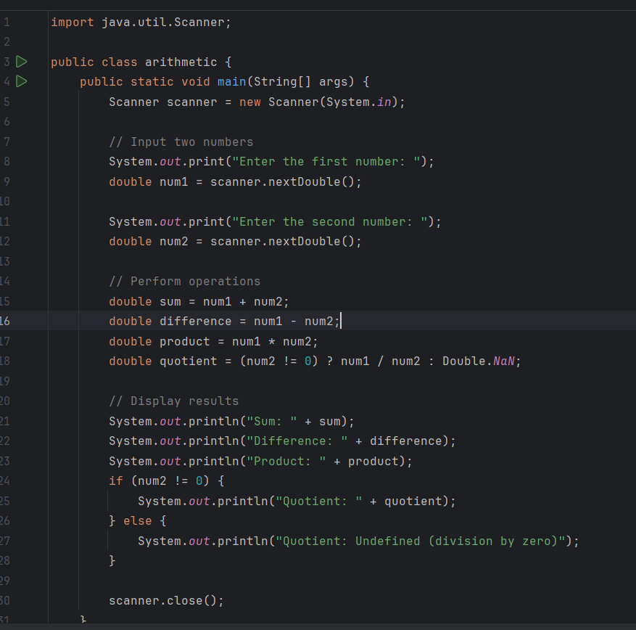

**OUTPUT:**

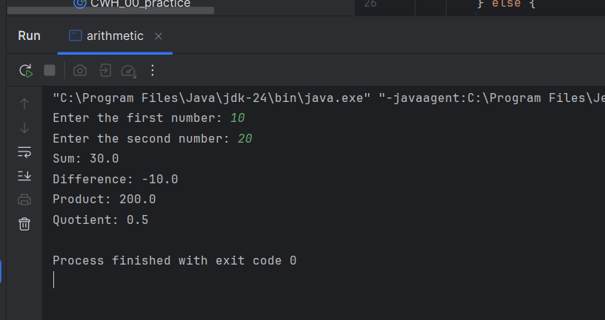

## Even or Odd Number

Write a program that asks the user to enter a number and prints whether it is even or odd.

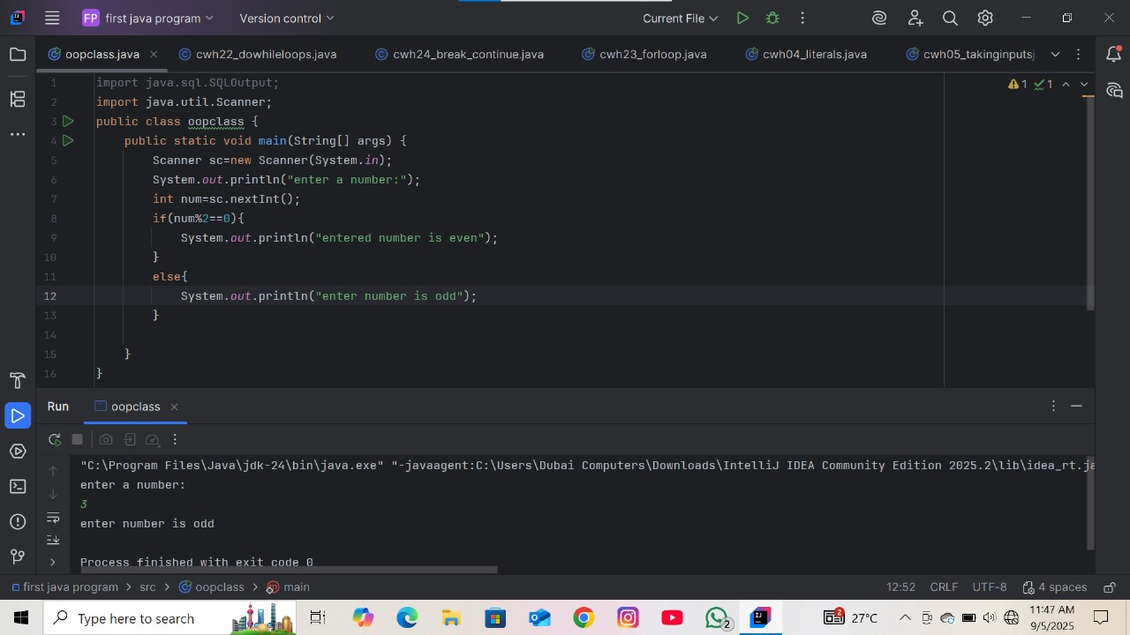

## Temperature Converter

Write a Java program to convert a temperature from Celsius to Fahrenheit. The formula is:

***Fahrenheit = (Celsius × 9/5) + 32***

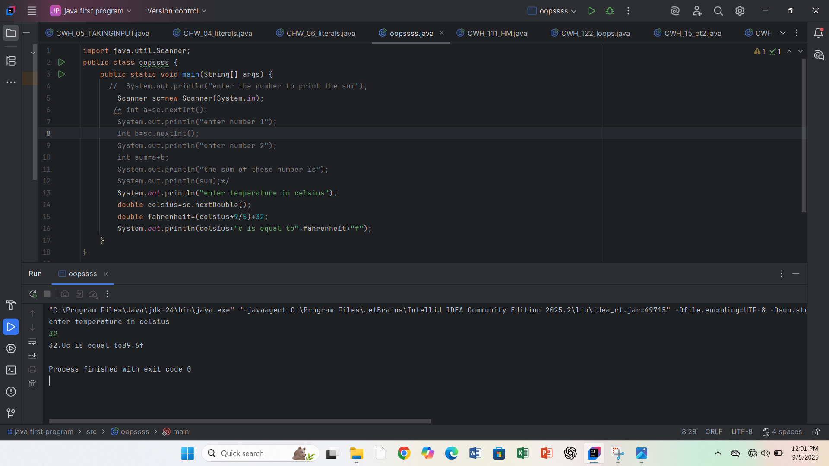

## Find the Largest Number

Write a program that asks the user to enter three numbers and prints the largest number among them.

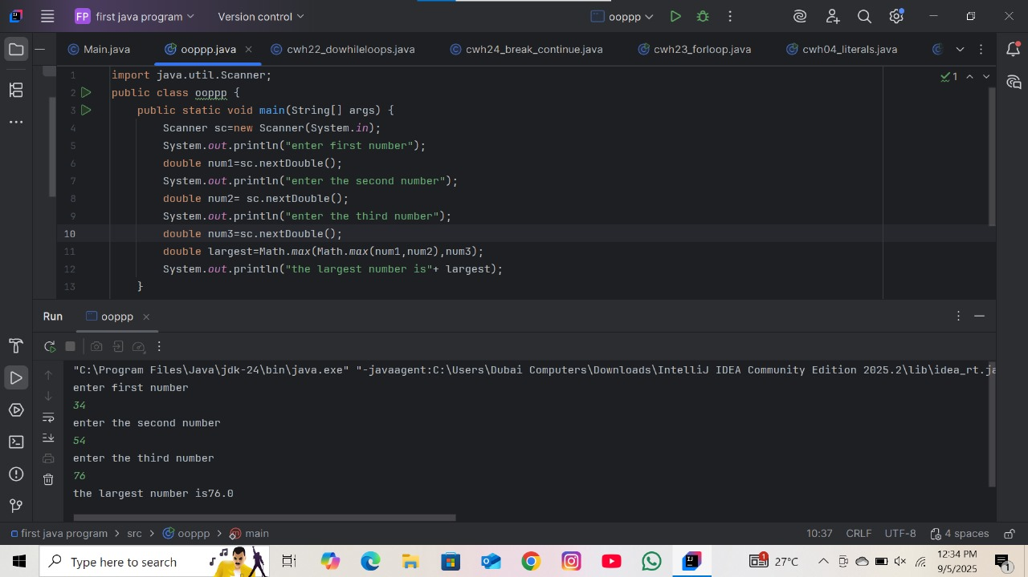

## Day of the Week Using Switch

Write a program that asks the user to enter a number (1–7) and prints the corresponding day of the week using a switch statement.

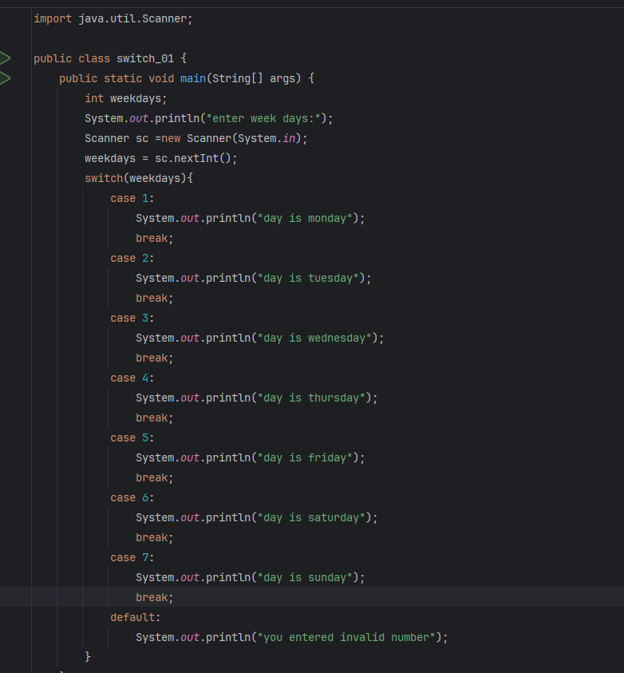

**OUTPUT:**

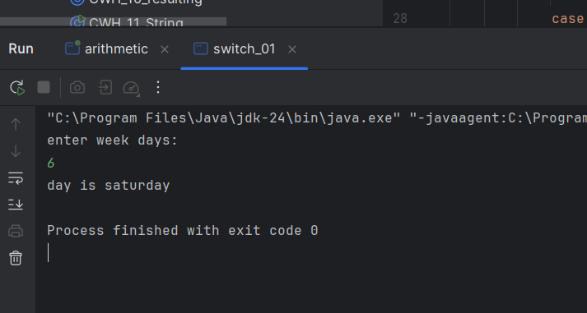

# Lab Task 03 – Java Basics Practice project Q1: Student Grade Calculator

**Topics Covered:**

Output, Comments, Variables, Data Types, Operators, Type Casting, If-Else Statements

# Instructions:

* Ask the user to enter marks for Quiz (out of 15), Assignment (out of 10), Mid-Term (out of 25), and Final Exam (out of 50).
* Store these values in variables of appropriate data types.
* Calculate Total Marks and Average (use type casting to show decimal values).
* Display the Grade using if-else.
* Add comments to explain your code.

# Grading Rules:

* Average >= 85 → Grade A
* 70 <= Average < 85 → Grade B
* 50 <= Average < 70 → Grade C
* Average < 50 → Fail

# Expected Output Example:

***Enter Quiz Marks: 12 Enter Assignment Marks: 9 Enter Mid-Term Marks: 20 Enter Final Marks: 40***

***Total Marks = 81 Average = 81.0 Grade = B***

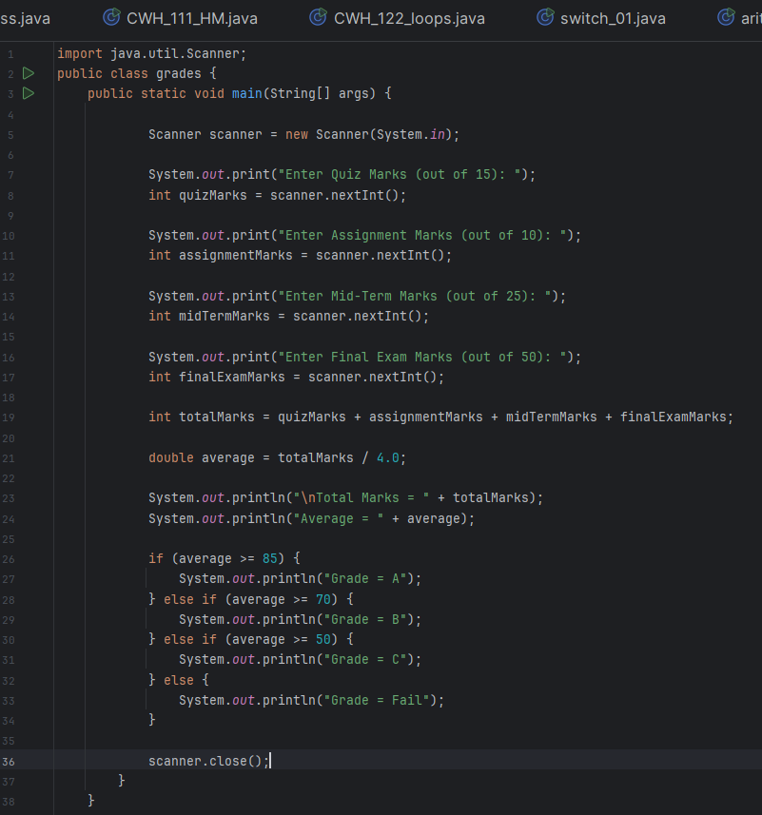

**OUTPUT:**

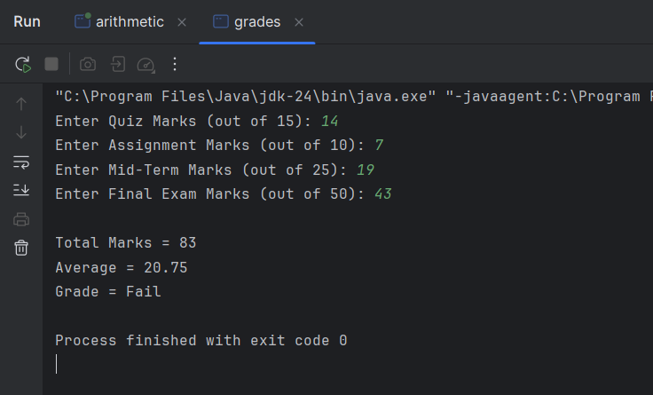

# Q2: Pizza Billing System Topics Covered:

Strings, If-Else, Switch, Math Operators, Booleans, Output and Comments

# Instructions:

* Ask the user for Pizza Size (small, medium, large).
* Use a switch statement to assign base prices: Small = 100, Medium = 200, Large = 300.
* Ask if the user wants pepperoni: Small → +30, Medium/Large → +50.
* Ask if the user wants extra cheese (+20).
* Display the final bill.

# Expected Output Example:

***Enter pizza size (small/medium/large): small Do you want pepperoni? (yes/no): yes***

***Do you want extra cheese? (yes/no): no Your final bill is: 130 rupees***

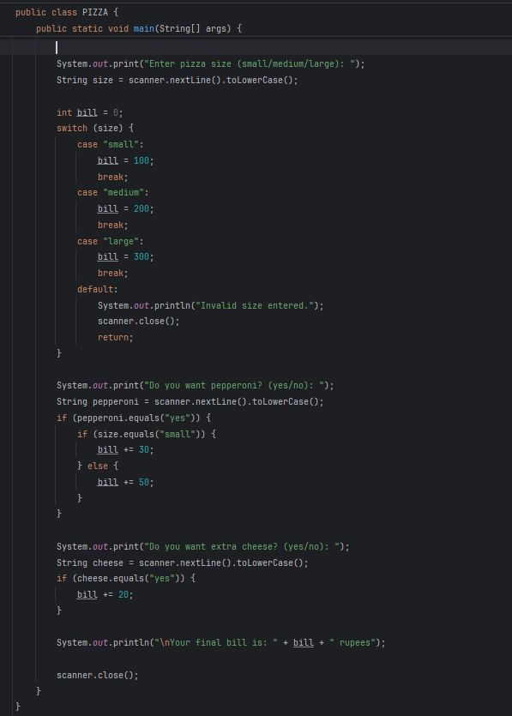

**OUTPUT:**

